American International University-Bangladesh (AIUB)  
Department of Computer Science  
Faculty of Science &Technology (FST)  
Summer 21 22

Section: B  
Software Quality Assurance and Testing

**E-commerce Management System**

A Report submitted By

|  |  |  |
| --- | --- | --- |
| SN | Student Name | Student ID |
| 1 | AUNOY, MAHMUDUL HASAN | 19-41110-2 |
| 2 | ANIK MALAKER | 19-41145-2 |
| 3 | BANIK TUSHER | 19-41017-2 |
| 4 | S A M SABIR | 18-38769-3 |

Under the supervision of   
 Abhijit Bhowmik

Associate Professor

Department of Computer Science

Faculty of Science & Technology

American International University-Bangladesh

Software Test Plan

for

E-commerce Management System

Version 1.0 approved

|  |
| --- |
| AUNOY, MAHMUDUL HASAN |
| ANIK MALAKER |
| BANIK TUSHER |
| S A M SABIR |

Prepared by

**Checked By**

Name: Esha Sheikh

Designation: Software Quality Assurance Engineer

Company: Dream 71

Sign:

Date:

Table of Contents

Revision History 4

1. TEST PLAN IDENTIFIER: RS-MTP01.3 4

2. REFERENCES 4

3. INTRODUCTION 4

Background to the Problem 4

Solution to the Problem 5

4. REQUEIREMNT SPECIFICATION 6-9

4.1 System Features 6-7

4.2 System Quality Attributes 7-8

4.3 System Interface 8-9

4.4 Project Requirements 9

5. FEATURES NOT TO BE TESTED 10-11

6. TESTING APPROACH 11

6.1 Testing Levels 11

6.2 Test Tools 12-16

6.3 Meetings 16

7. TEST CASES/TEST ITEMS 16-23

8. ITEM PASS/FAIL CRITERIA 23

9. TEST DELIVERABLES 24

10. STAFFING AND TRAINING NEEDS 24

11. RESPONSIBILITIES 25

12. TESTING SCHEDULE 26-28

13. PLANNING RISKS AND CONTINGENCIES 28

14. APROVALS 29

**Revision History**

|  |  |  |  |
| --- | --- | --- | --- |
| Revision | Date | Updated by | Update Comments |
| 0.1 | 2022.08.08 | S A M SABIR | First Draft |
| 0.2 | 2022.08.08 | ANIK MALAKER | Second Draft |
| 0.3 | 2022.08.08 | BANIK TUSHER | Third Draft |
| 0.4 | 2022.08.09 | AUNOY,MAHMUDUL HASAN | Fourth Draft |
| 0.5 | 2022.08.09 | BANIK TUSHER | Fifth Draft |
| 0.6 | 2022.08.09 | ANIK MALAKER | Sixth Draft |
| 0.7 | 2022.08.10 | AUNOY,MAHMUDUL HASAN | Seventh Draft |
| 0.8 | 2022.08.11 | S A M SABIR | Eighth Draft |
|  |  |  |  |

1. **TEST PLAN IDENTIFIER: RS-MTP01.3**
2. **REFERENCES**

a. Software Quality And Testing Course PowerPoint Slides

b. Software Requirement Specification (SRS) Document

c . Online Shopping System software requirements specification

[https://www.studocu.com/in/document/amrita-vishwa-vidyapeetham/software-project- management/srs-online-shopping-system/27748532](https://www.studocu.com/in/document/amrita-vishwa-vidyapeetham/software-project-%20management/srs-online-shopping-system/27748532)

**E-commerce Management System**

**3. INTRODUCTION**

**3.1 Background to the Problem**

E-commerce Management System is an online solution that will make easy online shopping. People who want to buy goods from sitting their home. They need a reliable solution that will help them by providing what they want. Many people who are always busy with their work and can’t go outside for shopping or buy necessary daily products. They also need a reliable solution. In a traditional store, there is a limit on product variety and customers have limited options and from these options, they have to buy. Going to market sometime people face traffic, it loses their valuable time. Going to the market also increases the expenses. All these problems have one solution and that is our E-commerce Management System.

* 1. **Solution to the Problem**
* To deal with the problems we want to build a system which will make the shopping process easy, with the help of it people can easily buy anything from their home. This solution is particularly appropriate to solve the problem because it solves the customer’s needs from every site.
* Yes, the solution is feasible to meet the business objective.
* The software is specified for the ones who are busy with their daily work and want to buy daily necessary goods from online.
* The purpose, objectives and goals of the software is to make online shopping system easy, saves people’s traveling time and traveling expenses.
* There are many benefits of using our E-commerce Management Systems. Such as:

1. Customers get Qualitiful Product with cheap rate.

2. Saves Customer’s traveling time and traveling expenses.

3. Customers get varities of products.

4. Buy from home.

5. Fast delivery system.

* There are many Existing studies available in this problem area. Ecommerce 101: The History and Future of Online Shopping and E-Commerce: Its Status and Impact on Business in Bangladesh are some examples of them.
* The existing software solutions that are available to solve the problem are Alibaba, Flipkart, Daraz, Amazon.com

**4. REQUEIREMNT SPECIFICATION**

4.1 System Features

The software will have the following features:

1. System Registration

Functional Requirements

1.1 Anyone can open a user account by doing registration

1.2 Provide Name, Email, Username, password etc.

1.5 submit and create

Priority Level: High

Precondition: Not any.

2. System Login

Functional Requirements

2.1 The software shall allow users to login with their given username and password

2.2 If the username or password has been inserted wrong user cann’t login to the site.

Priority Level: High

Precondition: user have valid user id and password

3. Add to Cart

Functional Requirements

3.1 User can add any product they want to buy to their cart.

Priority Level: Medium

Precondition: Verify Login

4. Empty Cart

Functional Requirements

4.1 User can add any product they want to buy to their cart.

Priority Level: Medium

Precondition: Products have to add cart first.

5. System Logout

Functional Requirements

2.1 User can logout from the site just by click logout button.

Priority Level: Low

Precondition: user has to login in first.

**4.2 System Quality Attributes**

Performance: Performance specifications outline how quickly or how well this system must execute particular functionalities. A testing method that assesses a computer, network, software application, or other device's speed, responsiveness, and stability when under load. Suppose our system developers can easily use customer product buy and order. The system makes sure the first and easy process paying system. Performance testing will be conducted by organizations to locate performance-related bottlenecks.

Efficiency: The effectiveness of test processes is determined by test efficiency. It verifies the number of resources needed and is applied to the project. This characteristic specified the best way to use the system. It deals with the hardware requirements for carrying out the various system functions. Processing power, storage space, and data communication power are all included. Our system online based so from the local server to the central Server our customer information is secured.

Integrity: It is a process in which data is verified in the database whether it is accurate and functions as per requirements. Integrity this factor deals with the system security that is, preventing access to unauthorized persons. This attribute is most important to provide security.

Reliability: This is an important software testing technique that is performed by the team to ensure that the software is performing and functioning consistently in each environmental condition as well as in a specified period. The reliability of a system is defined by how reliable it uses this system. Suppose when a customer buys or orders you’re necessary product and pays money how to ensure your ordering product correctly reached the location.

Testability: If the System faces any error or defect then it must have the testing ability of that error or defect.

4.3 System Interfaces:

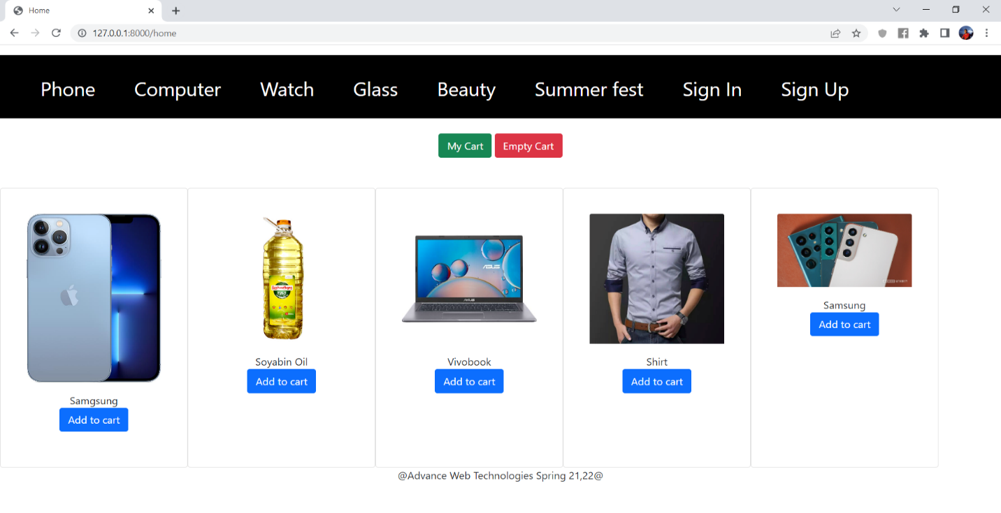

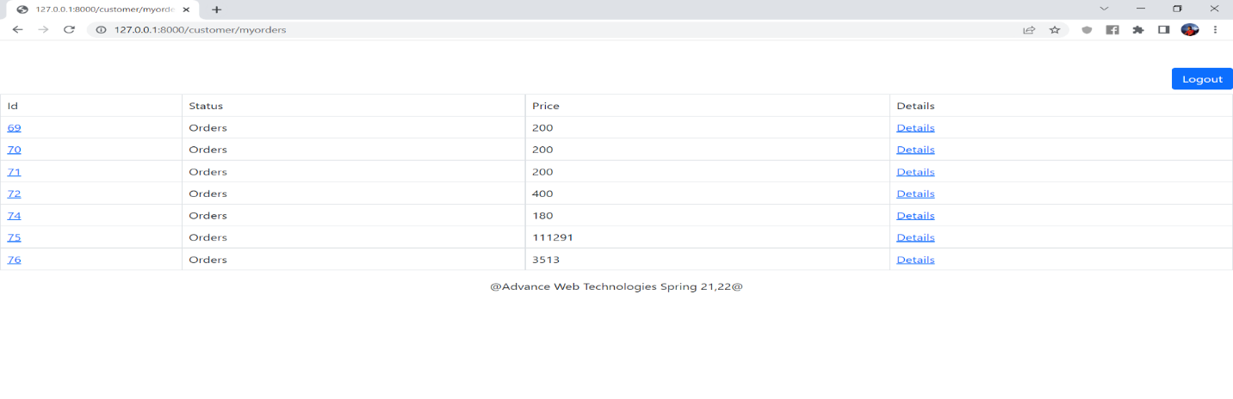

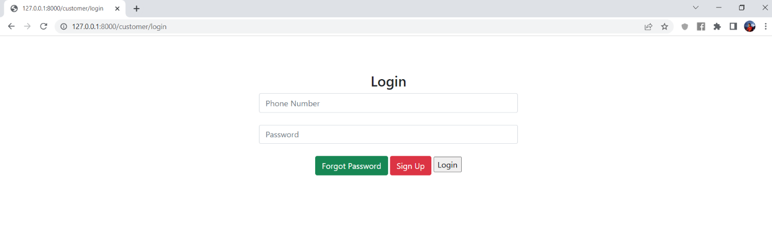

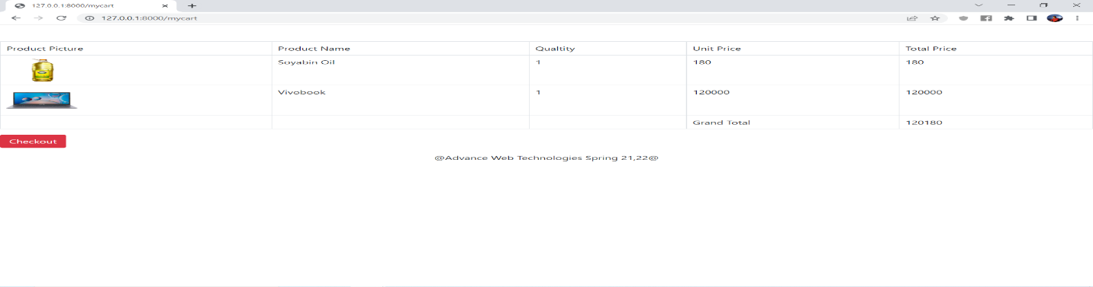

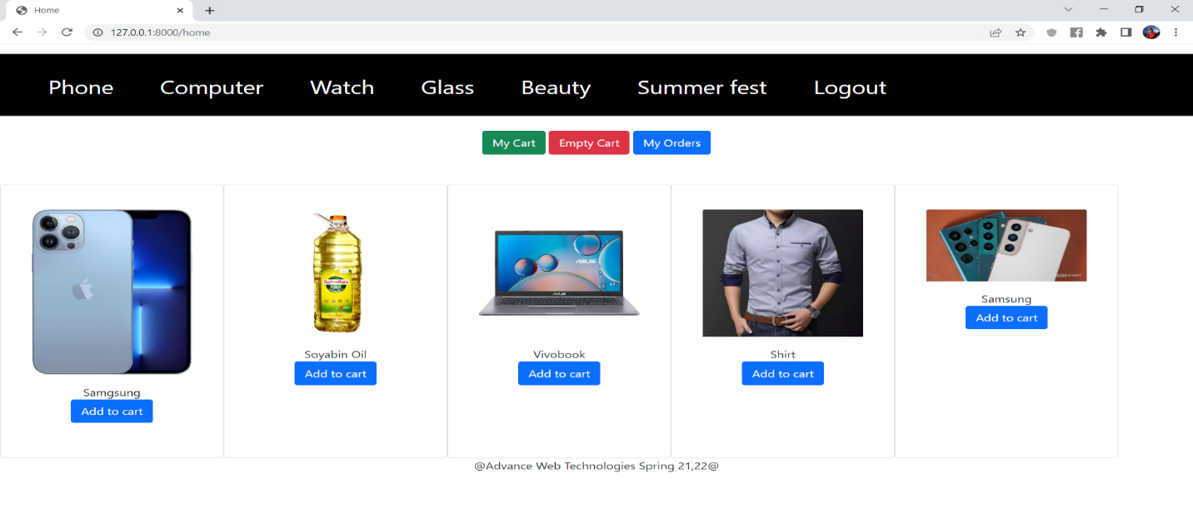

4.4 Project Requirements

* Need team of 3 developer and 1 Senior developer.
* Need 1 UI/Ux designer.
* Need a Workspace where the employees can work.
* Need some Premium Softwares
* Calculating proper time estimation:

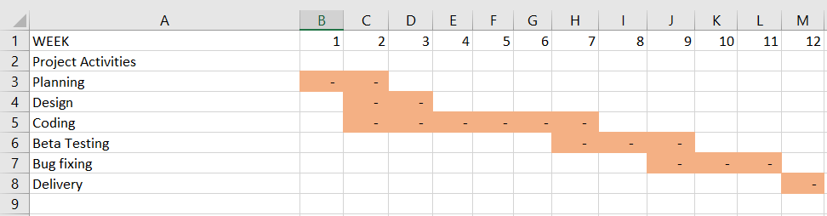

* Calculating proper budget estimation:

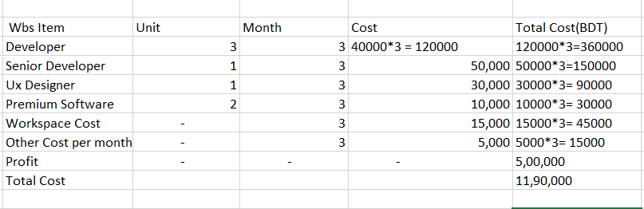

**5. FEATURES NOT TO BE TESTED**

* Variety of products.
* Maintenance of servers.
* Customer Payment method.
* User account security.
* Network facilities
* Buyer transection records.

**6. TESTING APPROACH**

6.1 Testing Levels

**Unit Testing:** First we will do the Unit Testing during our system development. We will test specific software modules as part of this testing to determine whether or not they contain errors. This testing methodology is done by the software developers and QA staff. This testing goal is to ensure that each unit of software code works as intended. Suppose our system has many modules like my cart, my order, etc. In this step, we will follow the “White Box Testing” technique.

**Integration Testing:** After that in the second part we will do the Integration. In this testing, we will make sure that all the software modules are integrated logically and tested as a group and working correctly. Suppose our system Add cart connected to my order and my cart if add cart select then store and show my order, my cart. The goal of this level of testing is to find flaws in the way various software modules interact when they're integrated. In this step, we will follow the “Bottom-up Integration” technique.

**System Testing:** Then we will do the system testing. Through the system testing, we will test the full-featured, fully integrated system. Then we will verify if it meets all the requirements. Black-box testing falls under this condition. Test overall system customer perspective properly works or not a system. Test functional or non-functional meets requirements. So, in this level, we will follow the “Black Box Testing” technique.

**Acceptance Testing:** The last phase of our testing is Acceptance Testing. This testing is done, by the client or user. If any defect identifies by the clients resolve it. We will do this Testing for checking the acceptability of our product. This test will be done to check whether any defect was missed during the functional testing phase. In this level, we will follow the “Black Box Testing” technique. After that, we may run unit tests again.

6.2 Testing Tool:

A testing tool is needed to be developed that can auto-generate the test results to the pre-defined form and automated test execution. We use selenium testing tool for testing and use it by java. For running the test faster the test needs to be run parallelly.

Registration Testing

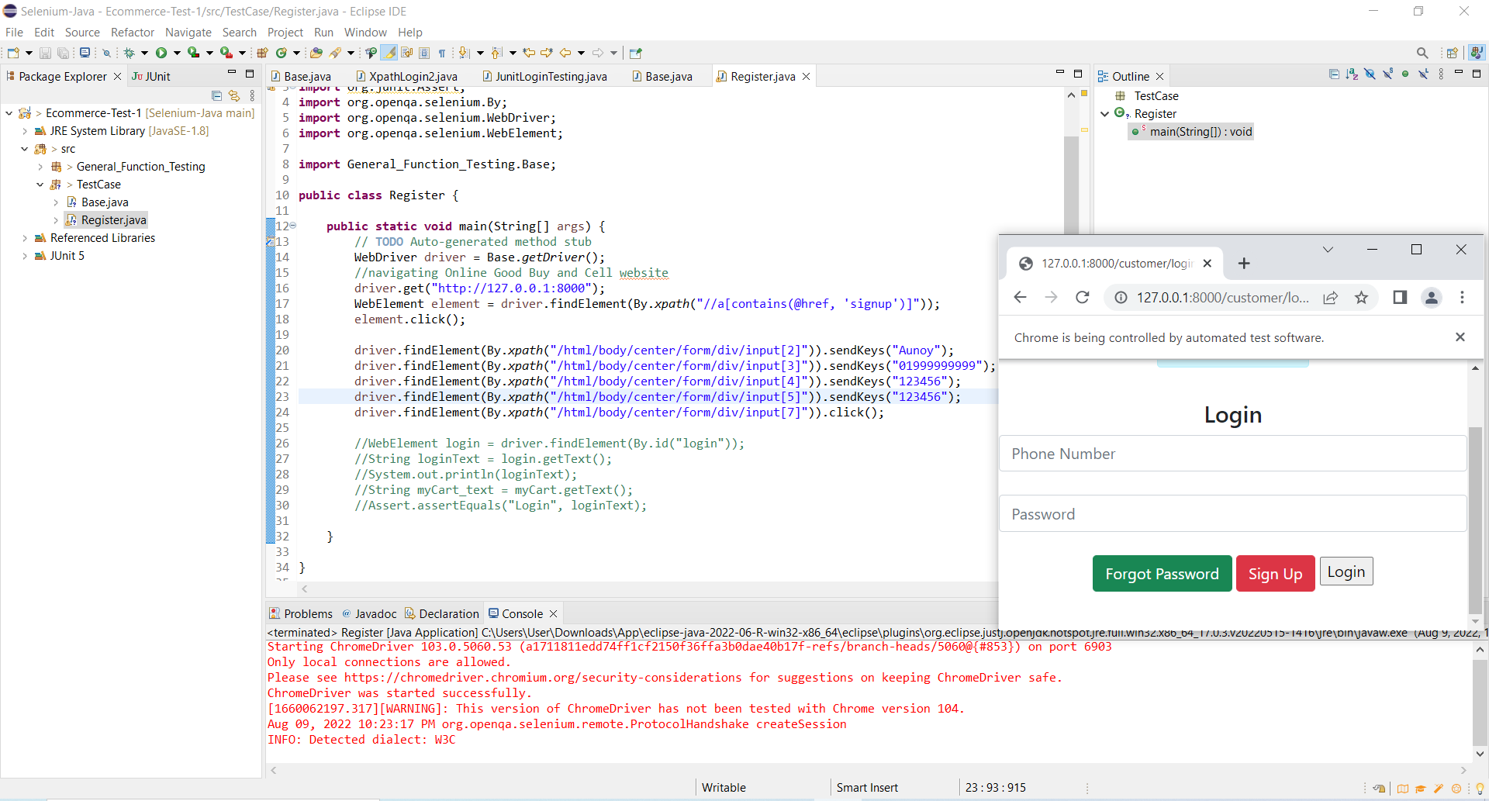

Login Testing

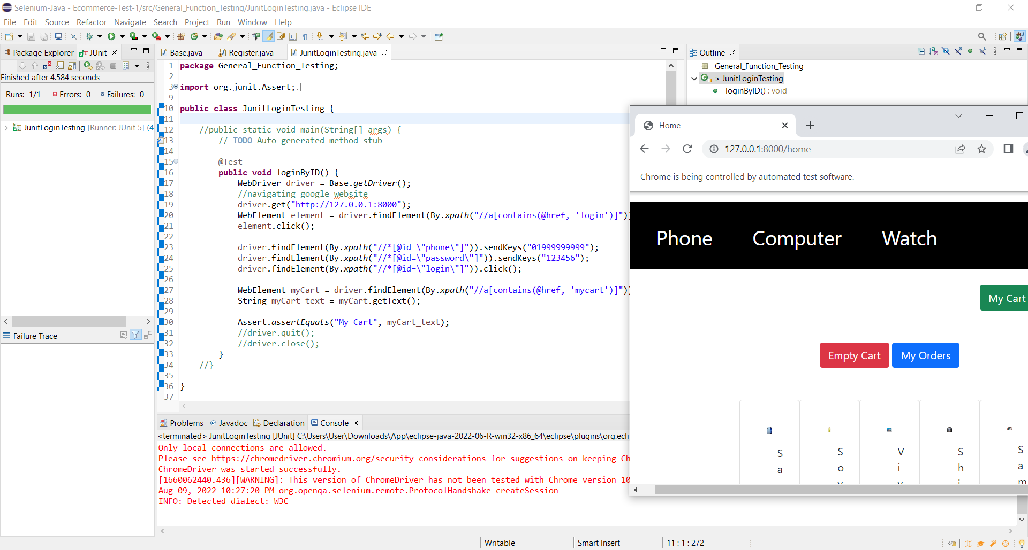

Login Testing by Wrong Password

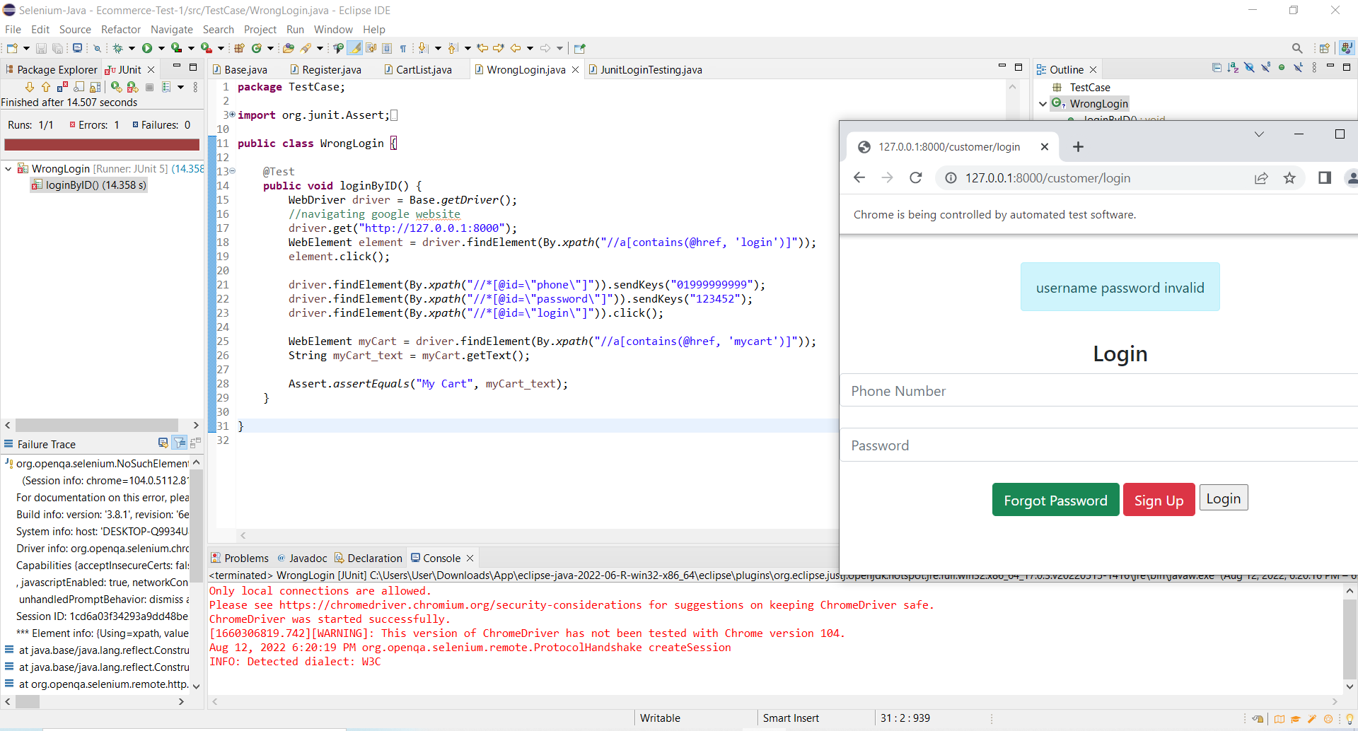

Check Out Testing

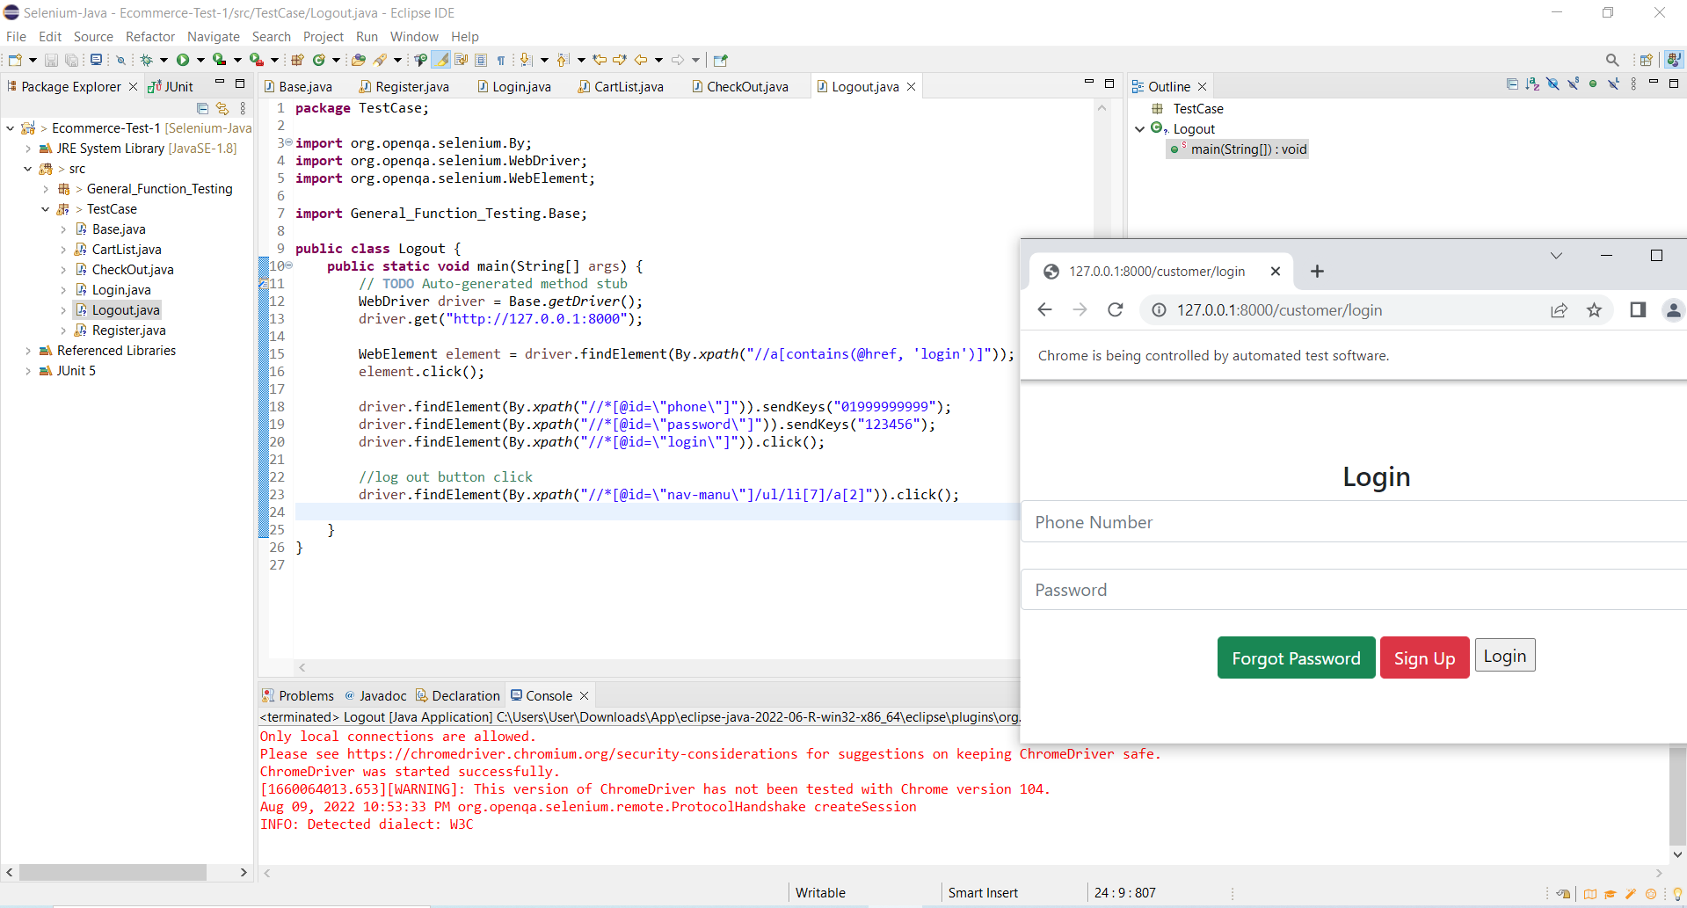

Add TO Cart Testing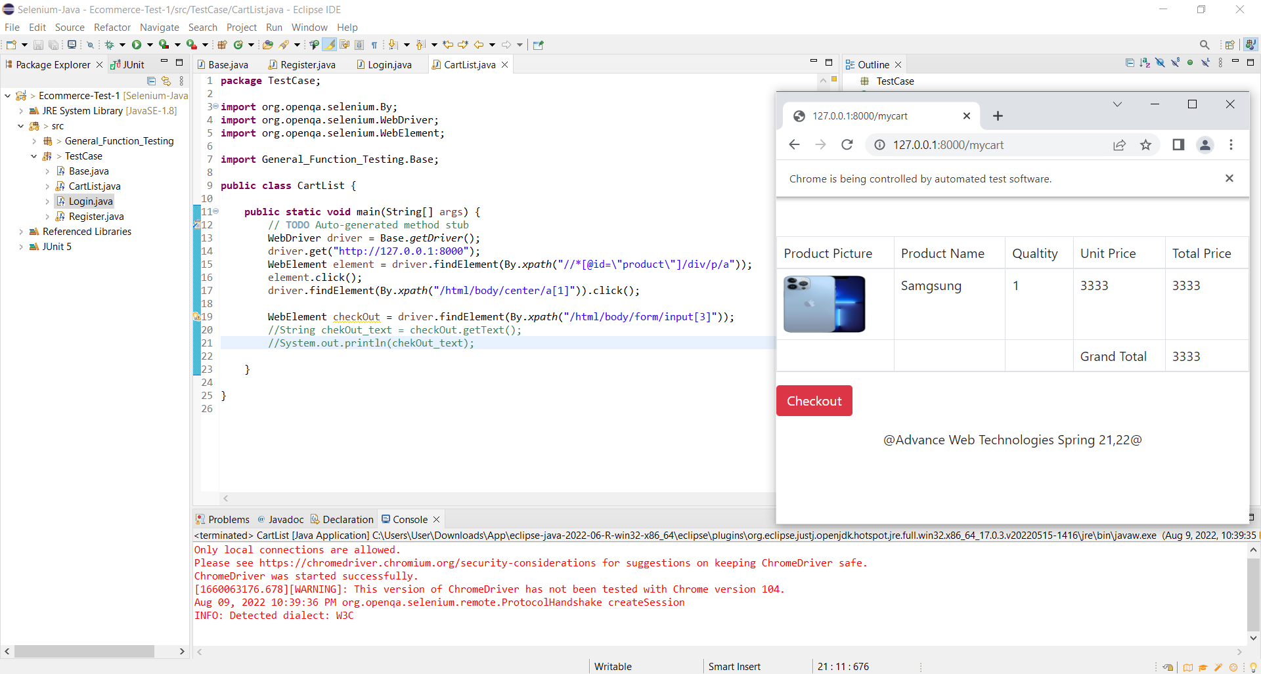

Checkout Testing

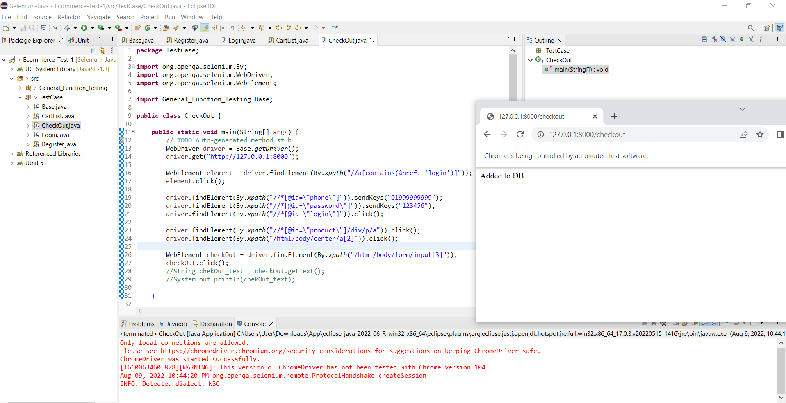

Change Password Testing

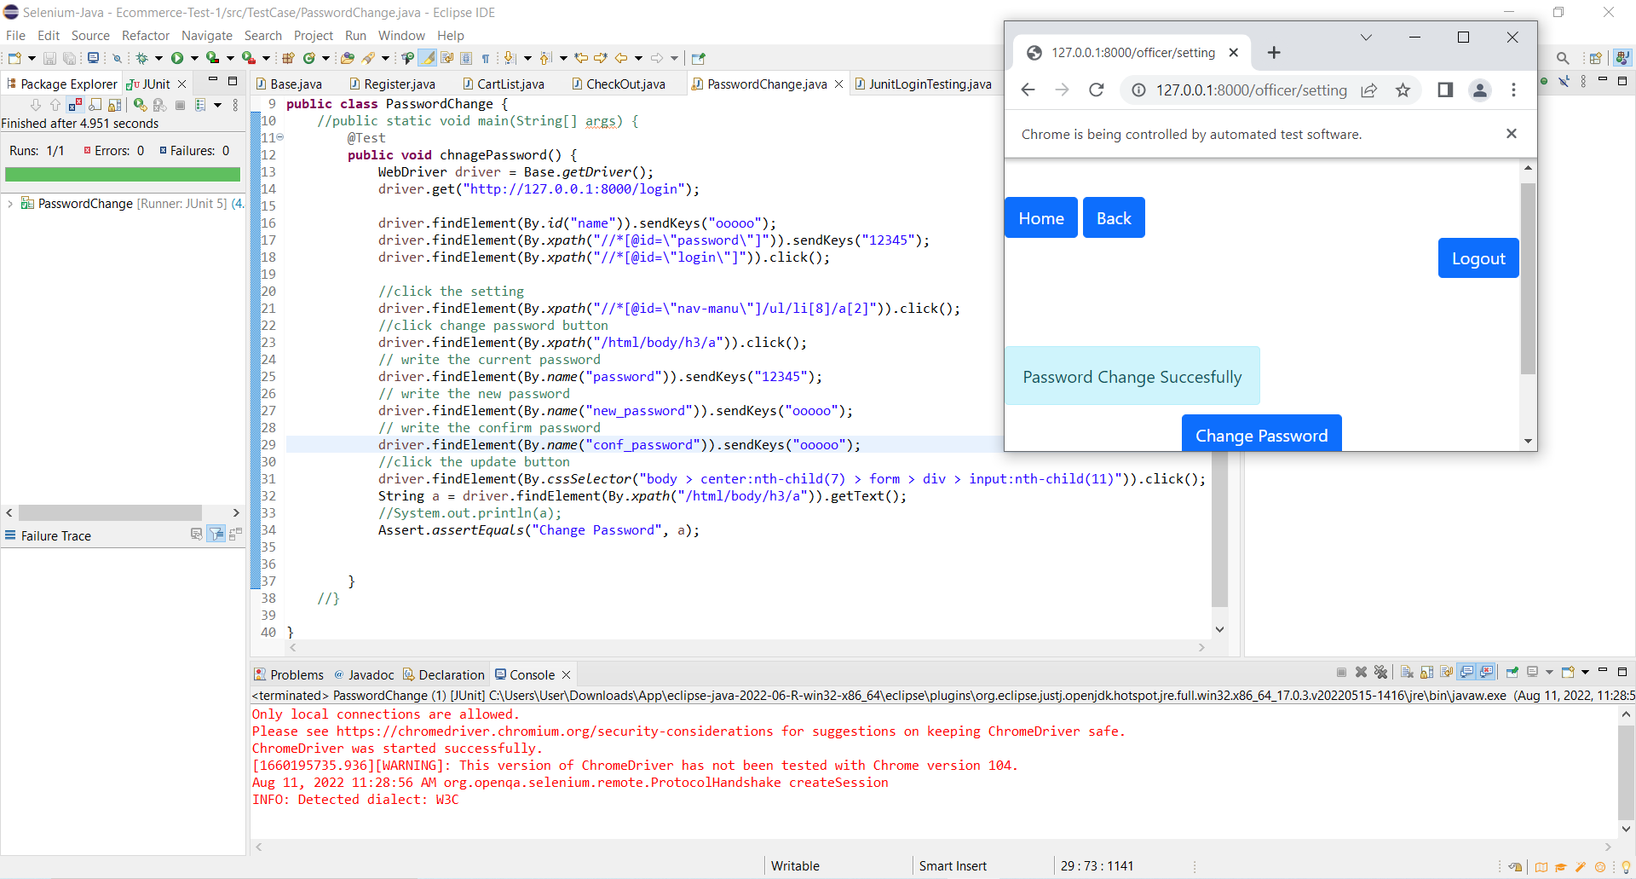

Show Product Testing

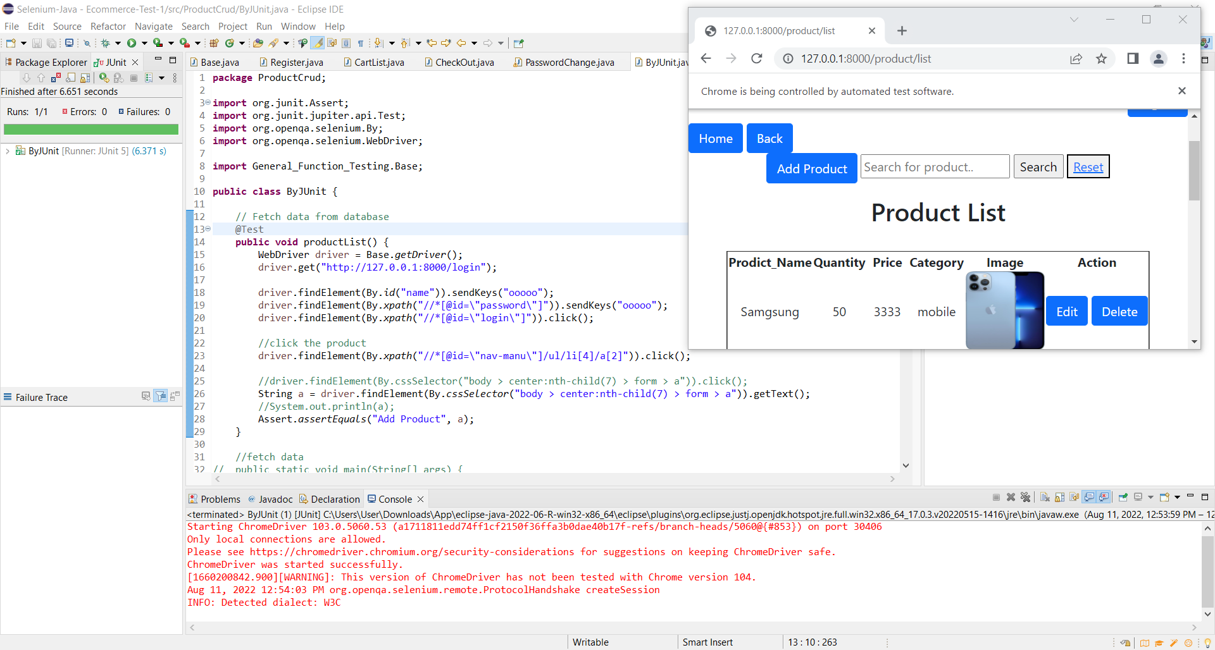

Delete Product Testing

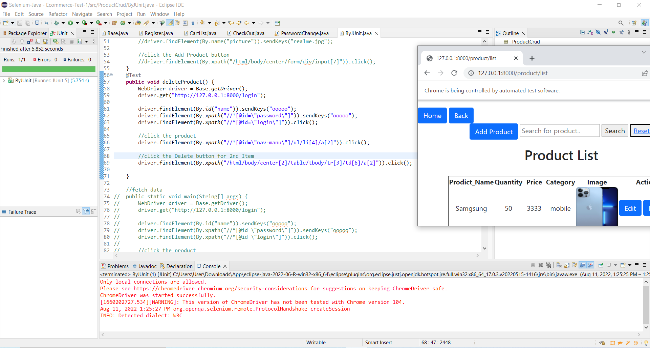

6.3. Meeting

One of the most crucial elements of developing a successful testing team is assigning the right work to the appropriate person. Therefore, it is essential to hold regular team meetings if you want to have a successful team. Once each work has been completed, the assigned tester may be checked, and any changes or defects can be fixed. In addition to this assignment, The test team will consequently convene once a week to assess each member's development and decide whether or not they have finished their assigned tasks. And find out if there are any problems with testing; if there are, the entire team will assist him and work to find a solution as quickly as possible. The testing team leaders and the project manager will have a weekly meeting. An emergency meeting will be scheduled if one is necessary.

**7. TEST CASES/TEST ITEMS**

**Test case 01:**

|  |  |  |  |  |  |
| --- | --- | --- | --- | --- | --- |
| Project Name: Ecommerce Management System | | | Test Designed by: Mahmudul Hasan Aunoy | | |
| Test Case ID: EMS_1 | | | Test Designed date: 04/08/2022 | | |
| Test Priority (Low, Medium, High): High | | | Test Executed by: Anik Malaker | | |
| Module Name: User Registration Session | | | Test Execution date: 06/08/2022 | | |
| Test Title: Validate registering an account providing only mandatory field for user. | | |  | | |
| Description: Test website registration page. | | |  | | |
| Precondition (If any): Open the localhost. | | | | | |
| Test Steps | Test Data | Expected Results | | Actual Results | Status  (Pass/Fail) |
| 1. Go to the website  2. Click the "Sign Up"  3. Enter a new account detail for the only mandatory field  4.Click on the Register button | URL: http://127.0.0.1:8000  Name: Aunoy  Phone: 01999999999  Password: 123456  Confirm Password:123456 | User should be logged in, taken to 'Account Success' page and proper details should be displayed on the page | | As expected, | Pass |
| Post Condition: User information saved into the database | | | | | |

**Test case 02:**

|  |  |  |  |  |  |
| --- | --- | --- | --- | --- | --- |
| Project Name: Ecommerce Management System | | | Test Designed by: Mahmudul Hasan Aunoy | | |
| Test Case ID: EMS_2 | | | Test Designed date: 04/08/2022 | | |
| Test Priority (Low, Medium, High): High | | | Test Executed by: Anik Malaker | | |
| Module Name: User Login Session | | | Test Execution date: 06/08/2022 | | |
| Test Title: Test the user login page. | | |  | | |
| Description: Test website login page. | | |  | | |
| Precondition (If any): Open the website. | | | | | |
| Test Steps | Test Data | Expected Results | | Actual Results | Status  (Pass/Fail) |
| 1. Go to the website  2. Click the "Sign In"  3. Enter a new account detail for the only mandatory field  4.Click on the Login button. | URL: http://127.0.0.1:8000  Phone: 01999999999  Password: 123456 | User should be logged in, taken to 'Account Success' page and proper details should be displayed on the page | | As expected, | Pass |
| Post Condition: User information saved into the database | | | | | |

**Test case 03:**

|  |  |  |  |  |  |
| --- | --- | --- | --- | --- | --- |
| Project Name: Ecommerce Management System | | | Test Designed by: Mahmudul Hasan Aunoy | | |
| Test Case ID: EMS_3 | | | Test Designed date: 04/08/2022 | | |
| Test Priority (Low, Medium, High): High | | | Test Executed by: Anik Malaker | | |
| Module Name: User Login Session | | | Test Execution date: 06/08/2022 | | |
| Test Title: Test the user login page. | | |  | | |
| Description: Test website Login page. | | |  | | |
| Precondition (If any): Open the website. | | | | | |
| Test Steps | Test Data | Expected Results | | Actual Results | Status  (Pass/Fail) |
| 1. Go to the website  2. Click the "Sign In"  3. Enter a new account detail for the only mandatory field  4. Click on the Login button. | URL: http://127.0.0.1:8000  Phone: 01999999999  Password: 123452 | User should not log in to the system. | | As expected, | Fail |
| Post Condition: User information saved into the database | | | | | |

**Test case 04:**

|  |  |  |  |  |  |
| --- | --- | --- | --- | --- | --- |
| Project Name: Ecommerce Management System | | | Test Designed by: Mahmudul Hasan Aunoy | | |
| Test Case ID: EMS_4 | | | Test Designed date: 04/08/2022 | | |
| Test Priority (Low, Medium, High): High | | | Test Executed by: Anik Malaker | | |
| Module Name: My Cart List Check | | | Test Execution date: 06/08/2022 | | |
| Test Title: View My Cart List | | |  | | |
| Description: Customer should view the Cart List | | |  | | |
| Precondition (If any): Open the website. | | | | | |
| Test Steps | Test Data | Expected Results | | Actual Results | Status  (Pass/Fail) |
| 1.Go to the Website  2. Click the "Sign In"  3. Enter a old account detail for the only mandatory field  4. Click the "Add To Cart" any product that are showed in the home page  5. Click the "My Cart" button | URL: http://127.0.0.1:8000  Phone: 01999999999  Password: 123456 | Customers should see their cart items. | | As expected, | Pass |
| Post Condition: All cart products will display and all carts will store in session. | | | | | |

**Test case 05:**

|  |  |  |  |  |  |
| --- | --- | --- | --- | --- | --- |
| Project Name: Ecommerce Management System | | | Test Designed by: Mahmudul Hasan Aunoy | | |
| Test Case ID: EMS_5 | | | Test Designed date: 04/08/2022 | | |
| Test Priority (Low, Medium, High): High | | | Test Executed by: Tusher Banik | | |
| Module Name: Empty Cart | | | Test Execution date: 06/08/2022 | | |
| Test Title: Cart List Remove | | |  | | |
| Description: Customers should remove their cart items. | | |  | | |
| Precondition (If any): Open the website. | | | | | |
| Test Steps | Test Data | Expected Results | | Actual Results | Status  (Pass/Fail) |
| 1. Go to the Website  2. Click the "Empty Cart" button | View the empty cart | Customer should see that cart is empty. | | As expected, | Pass |
| Post Condition: | | | | | |

**Test case 06:**

|  |  |  |  |  |  |
| --- | --- | --- | --- | --- | --- |
| Project Name: Ecommerce Management System | | | Test Designed by: Mahmudul Hasan Aunoy | | |
| Test Case ID: EMS_6 | | | Test Designed date: 04/08/2022 | | |
| Test Priority (Low, Medium, High): High | | | Test Executed by: Anik Malakar | | |
| Module Name: User Log Out | | | Test Execution date: 06/08/2022 | | |
| Test Title: Log Out | | |  | | |
| Description: Test website Log out button. | | |  | | |
| Precondition (If any): Must log in to the website. | | | | | |
| Test Steps | Test Data | Expected Results | | Actual Results | Status  (Pass/Fail) |
| 1. Go to the Website  2. Click the "Sign In"  3. Enter a new account detail for the only mandatory field  4.Click on the SIGN-UP button  5. Click Log out button | Phone: 01999999999  Password: 123456 | User Should go to the log in page. | | As expected, | Pass |
| Post Condition: | | | | | |

**Test case 07:**

|  |  |  |  |  |  |
| --- | --- | --- | --- | --- | --- |
| Project Name: Ecommerce Management System | | | Test Designed by: Mahmudul Hasan Aunoy | | |
| Test Case ID: EMS_7 | | | Test Designed date: 04/08/2022 | | |
| Test Priority (Low, Medium, High): High | | | Test Executed by: Anik Malakar | | |
| Module Name: Order Details List | | | Test Execution date: 06/08/2022 | | |
| Test Title: Order Details | | |  | | |
| Description: Check the order details. | | |  | | |
| Precondition (If any): User must login to the account. | | | | | |
| Test Steps | Test Data | Expected Results | | Actual Results | Status  (Pass/Fail) |
| 1. Go to the Website  2. Click the "Sign In"  3. Enter old account detail for the only mandatory field  4.Click on the SIGN-UP button  5. Click My Orders button | URL: http://127.0.0.1:8000  Phone: 01999999999  Password: 123456 | User must see the order details. | | As expected, | Pass |
| Post Condition: | | | | | |

**Test case 08:**

|  |  |  |  |  |  |
| --- | --- | --- | --- | --- | --- |
| Project Name: Ecommerce Management System | | | Test Designed by: Mahmudul Hasan Aunoy | | |
| Test Case ID: EMS_8 | | | Test Designed date: 04/08/2022 | | |
| Test Priority (Low, Medium, High): High | | | Test Executed by: Anik Malakar | | |
| Module Name: Cart session database | | | Test Execution date: 06/08/2022 | | |
| Test Title: Insert cart items to the database | | |  | | |
| Description: Test the cart items are inserted in database | | |  | | |
| Precondition (If any): Must Login the website and must have cart items. | | | | | |
| Test Steps | Test Data | Expected Results | | Actual Results | Status  (Pass/Fail) |
| 1. Go to the Web Site  2. Click the "Register"  3. Enter old account detail for the only mandatory field  4. Click the "Add To Cart" any product that are showed in the home page  5.Click on the My Cart Button  6. Click Check Out button | URL: http://127.0.0.1:8000  Phone: 01999999999  Password: 123456 | User can buy the product. | | As expected, | Pass |
| Post Condition: Cart items saved into the database | | | | | |

**Test case 09:**

|  |  |  |  |  |  |  |
| --- | --- | --- | --- | --- | --- | --- |
| Project Name: Ecommerce Management System | | | Test Designed by: Mahmudul Hasan Aunoy | | | |
| Test Case ID: EMS_9 | | | Test Designed date: 04/08/2022 | | | |
| Test Priority (Low, Medium, High): High | | | Test Executed by: Anik Malakar | | | |
| Module Name: Change Password | | | Test Execution date: 06/08/2022 | | | |
| Test Title: Password Change for Employee | | |  | | | |
| Description: Test website setting and change password page. | | |  | | | |
| Precondition (If any): Must login the website | | | | | | |
| Test Steps | Test Data | Expected Results | | Actual Results | Status  (Pass/Fail) |
| 1. Go to the Website  2. Click the "Login"  3. Enter old account detail for the only mandatory field  4.Click on the SIGN-UP button.  5. Click the Setting  6. Click the “Change Password”  7. Enter new password details for the only mandatory field | URL: http://127.0.0.1:8000/login  Name: ooooo  Password: 12345  Current Password: 12345  New Password: ooooo  Confirm Password: ooooo | User should update his password and can login with the new password. | | As expected, | Pass |
| Post Condition: User must go to the Password Change Page | | | | | | |

**Test case 10:**

|  |  |  |  |  |  |
| --- | --- | --- | --- | --- | --- |
| Project Name: Ecommerce Management System | | | Test Designed by: Mahmudul Hasan Aunoy | | |
| Test Case ID: EMS_10 | | | Test Designed date: 04/08/2022 | | |
| Test Priority (Low, Medium, High): High | | | Test Executed by: Tusher Banik | | |
| Module Name: Delete Product | | | Test Execution date: 06/08/2022 | | |
| Test Title: Delete a product | | |  | | |
| Description: Test website product page. | | |  | | |
| Precondition (If any): Must need to login the website. | | | | | |
| Test Steps | Test Data | Expected Results | | Actual Results | Status  (Pass/Fail) |
| 1. Go to the Website  2. Enter old account detail for the only mandatory field  3.Click on the Login button.  4. Click the Product Button  5. Click any Delete Button form the product list | URL: http://127.0.0.1:8000/login  Name: ooooo  Password: ooooo | User should see the updated product list after deleting a product. | | As expected, | Pass |
| Post Condition: Product will be removed form the database and also from the product list. | | | | | |

**Test case 11:**

|  |  |  |  |  |  |
| --- | --- | --- | --- | --- | --- |
| Project Name: Ecommerce Management System | | | Test Designed by: Mahmudul Hasan Aunoy | | |
| Test Case ID: EMS_11 | | | Test Designed date: 04/08/2022 | | |
| Test Priority (Low, Medium, High): High | | | Test Executed by: Tusher Banik | | |
| Module Name: Fetch Data from Database | | | Test Execution date: 06/08/2022 | | |
| Test Title: Show Product List | | |  | | |
| Description: Test website product page. | | |  | | |
| Precondition (If any): Must need to login the website. | | | | | |
| Test Steps | Test Data | Expected Results | | Actual Results | Status  (Pass/Fail) |
| 1. Go to the Website  2. Enter old account detail for the only mandatory field  3. Click on the Login button.  4. Click the Product Button | URL: http://127.0.0.1:8000/login  Name: ooooo  Password: ooooo | User must can see the product list. | | As expected, | Pass |
| Post Condition: Product list will show. | | | | | |

**8. ITEM PASS/FAIL CRITERIA**

The test case was completed successfully and expected outcome is 90%. We tested all the test cases without one. That one test case was failed that is Insert Product. After we did it partially. Half automated and half manual.

**9. TEST DELIVERABLES**

**•** Test specification document: Ready to system summary and scenario then tested.

• Test strategy: The high-level document defines the testing approach

• Test scenario: We have to follow and test every process system in detail.

• Defect reports: Bug report of a feature.

• Test design: We follow all approaches formal way to design tests.

• Test status report: Way the development of the application.

• Summary of all reports: Summary of testing, overall opinions, and test pass/fail.

**10. STAFFING AND TRAINING NEEDS**

The following staffing is necessary for the test plan:

• Test Analyst (1)

• Developer (1)

• Project Manager / Test manager (1)

For the project's integration and acceptance testing stages, one Test Analyst is needed to allocate to the task. For approving test plans, participating in evaluations, meetings and other managerial tasks a project manager will need to be allocated from the beginning of the project. A developer is a must for providing the test items with their associated transmittal reports and ensuring that the test personnel can properly connect the equipment

Along with the staffing, training needs is included learning testing methodologies, interfacing systems, and using of some appropriate tools.

**11. RESPONSIBILITIES**

The following roles are defined in this test plan:

•Project Manager –

The Project Manager shall be responsible for:

Approving the Test Plan;

Working with the Test Manager to address any concerns (e.g., balancing the desire for a perfect implementation against the political pressure to finish the project);

Providing the test environment;

Witnessing the performance of the tests;

Receiving and checking the test results; and

Final acceptance of the component.

•Test Analyst –

The Test Analyst shall be responsible for:

Designing any custom test procedures;

Preparing the test environment; and

Executing the tests according to the test plan.

•Test Manager –

The Test Manager shall be responsible for:

Managing the overall testing process and the test personnel;

Finalizing the test plan;

Providing the test tools; and Checking the test results.

•Developer –

The Developer shall be responsible for:

Providing the test items with their associated transmittal reports;

Ensuring that the test personnel can properly connect the equipment;

(Optionally) witnessing the performance of the tests;

Checking the test results; and

Resolving any areas of non-conformance identified.

**12. TESTING SCHEDULE**

The following testing activity is in our project plan. The project plan a particular month, week, and day. Each procedure included a time schedule. The test team, development team, management, and customer personnel needed for each assignment will be coordinated by the project manager in conjunction with the development and test team leaders.

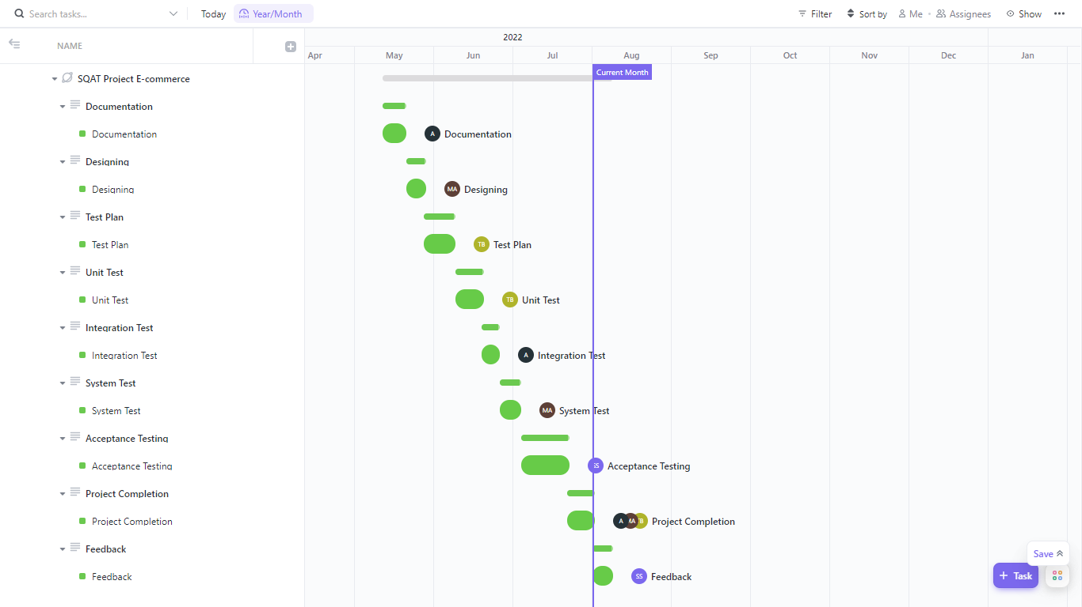

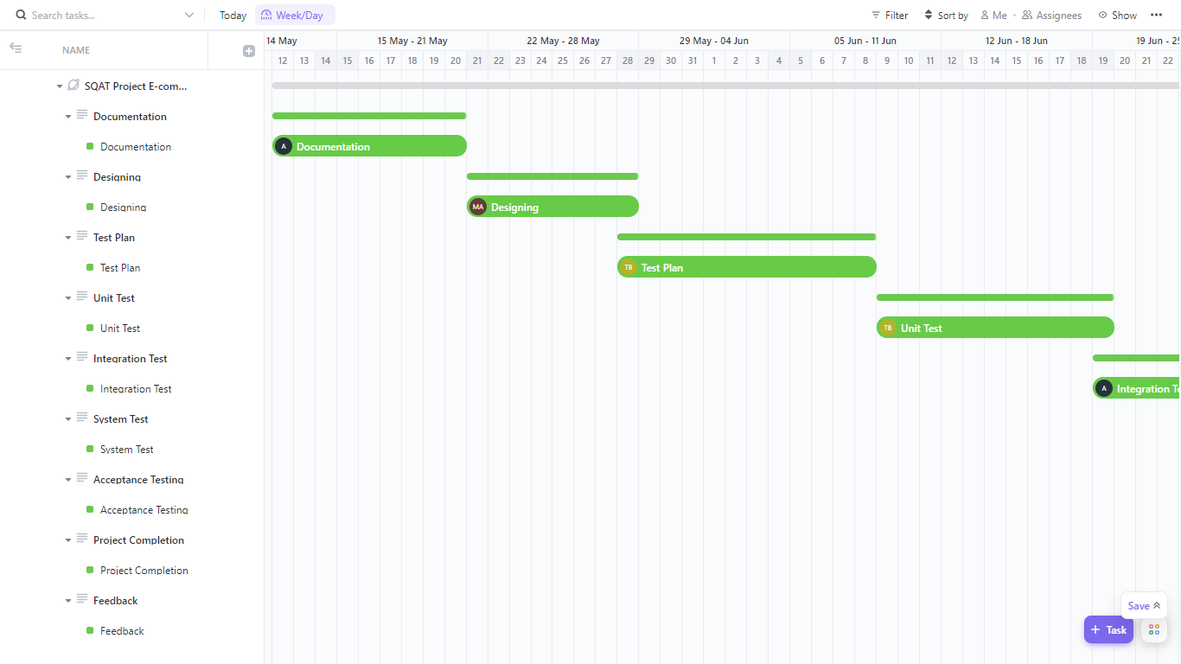

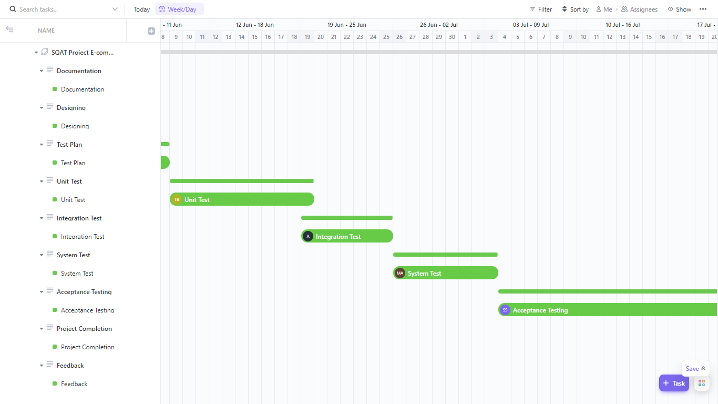

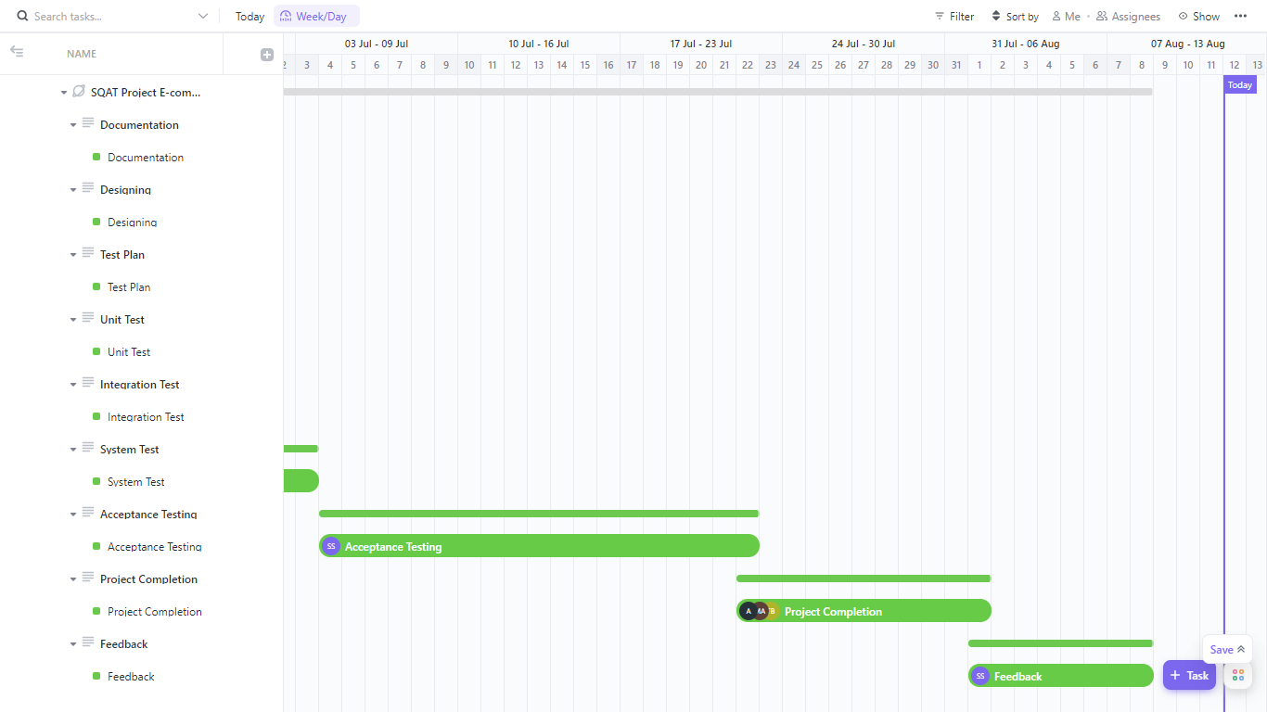

**13. PLANNING RISKS AND CONTINGENCIES**

Few Sales personnel have been reassigned. There are presently two open vacancies in the Reassigned Sales administrative team. Due to this personnel shortfall, it can take longer to obtain workers to evaluate pertinent papers and take part in the acceptance test procedure. The proper dates for reviews and acceptance testing will change following any issues with client employees. The evaluation and testing procedures will not be circumvented in any way.

**14.APROVALS**

|  |  |
| --- | --- |
| Project Sponsor | Sam Sabir |
| Development Management | Mahmudul Hasan Aunoy |
| EDI Project Manager | Mahmudul Hasan Aunoy |
| RS Test Manager | Tusher Banik |
| RS Development Team Manager | Anik Malaker |
| Reassigned Sales | Tuhser Banik, Anik Malakar |
| Order Entry EDI Team Manager | Mahmudul Hasan Aunoy, Sam Sabir |